

FACULTY OF INFORMATION AND COMMUNICATION TECHNOLOGY

DCOMP204 – WEB DESIGN 1

Title : Individual Assignment 2
Issue Date : Week 4
Due Date : Week 9
Lecturer/Examiner : Cornelious M Grant
Name of Student/s : Isatu Bah
Student ID No. : 905005498
Class : BIT 1102F
Year/Semester : 2/1

Academic Honesty Policy Statement

I/We, hereby attest those contents of this attachment are my own work. Referenced works, articles, art, programs, papers or parts thereof are acknowledged at the end of this paper. This includes data excerpted from CD-ROMs, the Internet, other private networks, and other people’s disk of the computer system.

Student’s Signature: Date: 29th NOVEMBER 2025
LECTURER’S COMMMENTS/GRADE:

for office use only upon receive
Remark

DATE:
TIME:
RECEIVER’S NAME:

HOME PAGE SCREENSHOT
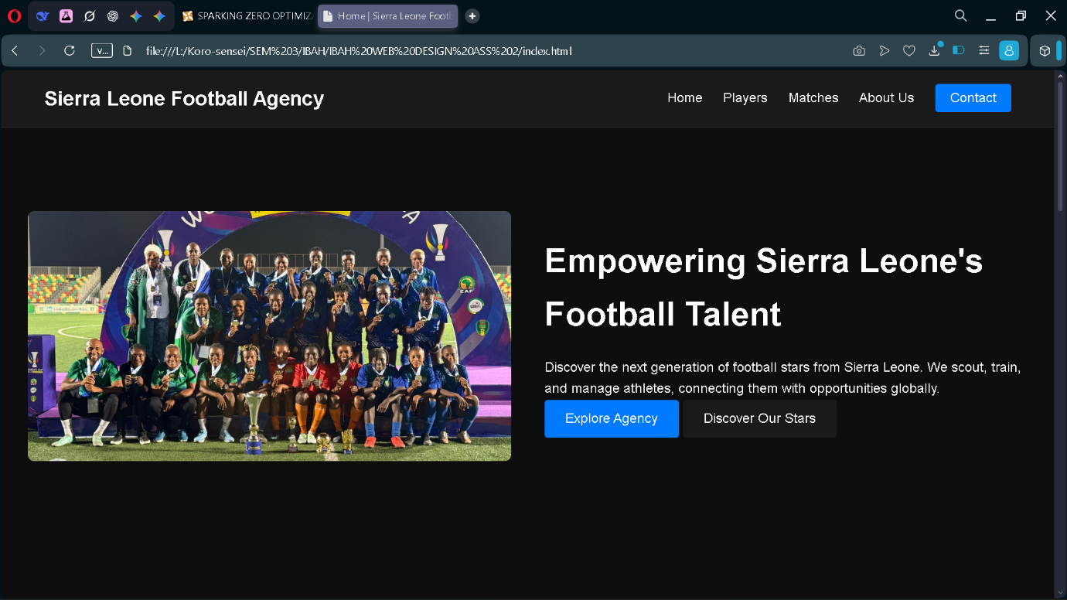

PLAYERS PAGE SCREENSHOT

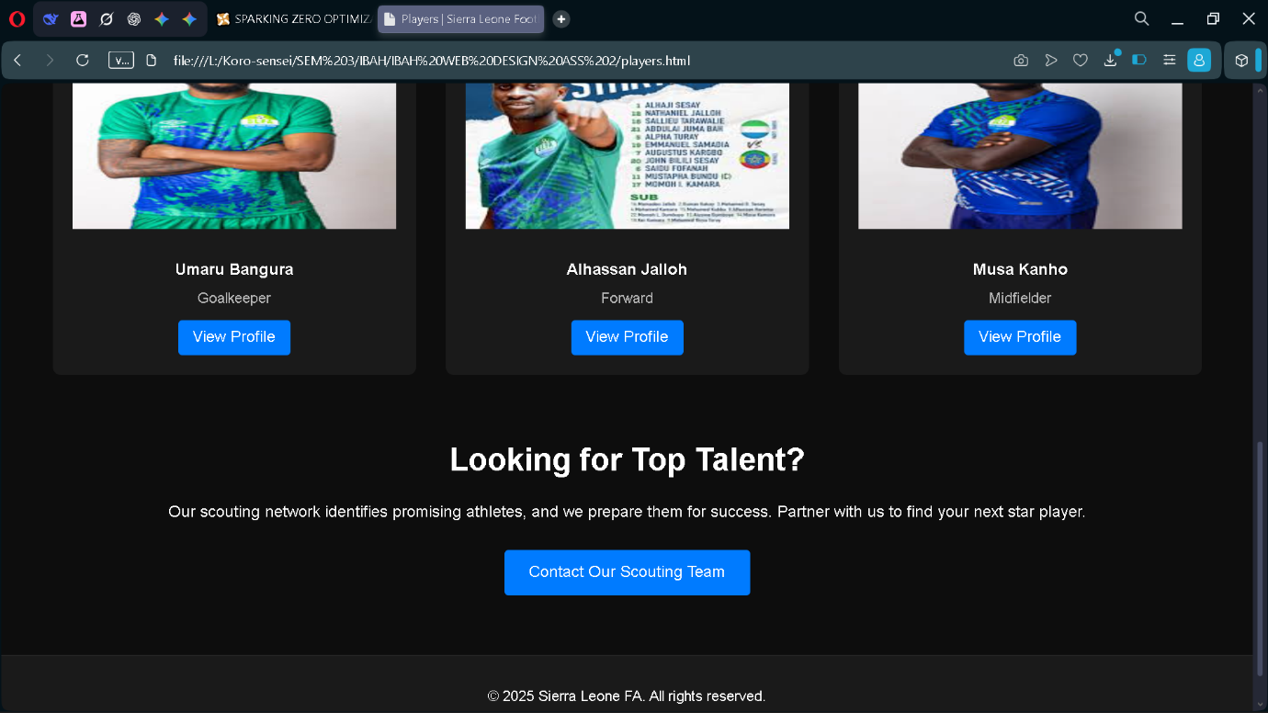

CONTACT PAGE SCREENSHOT
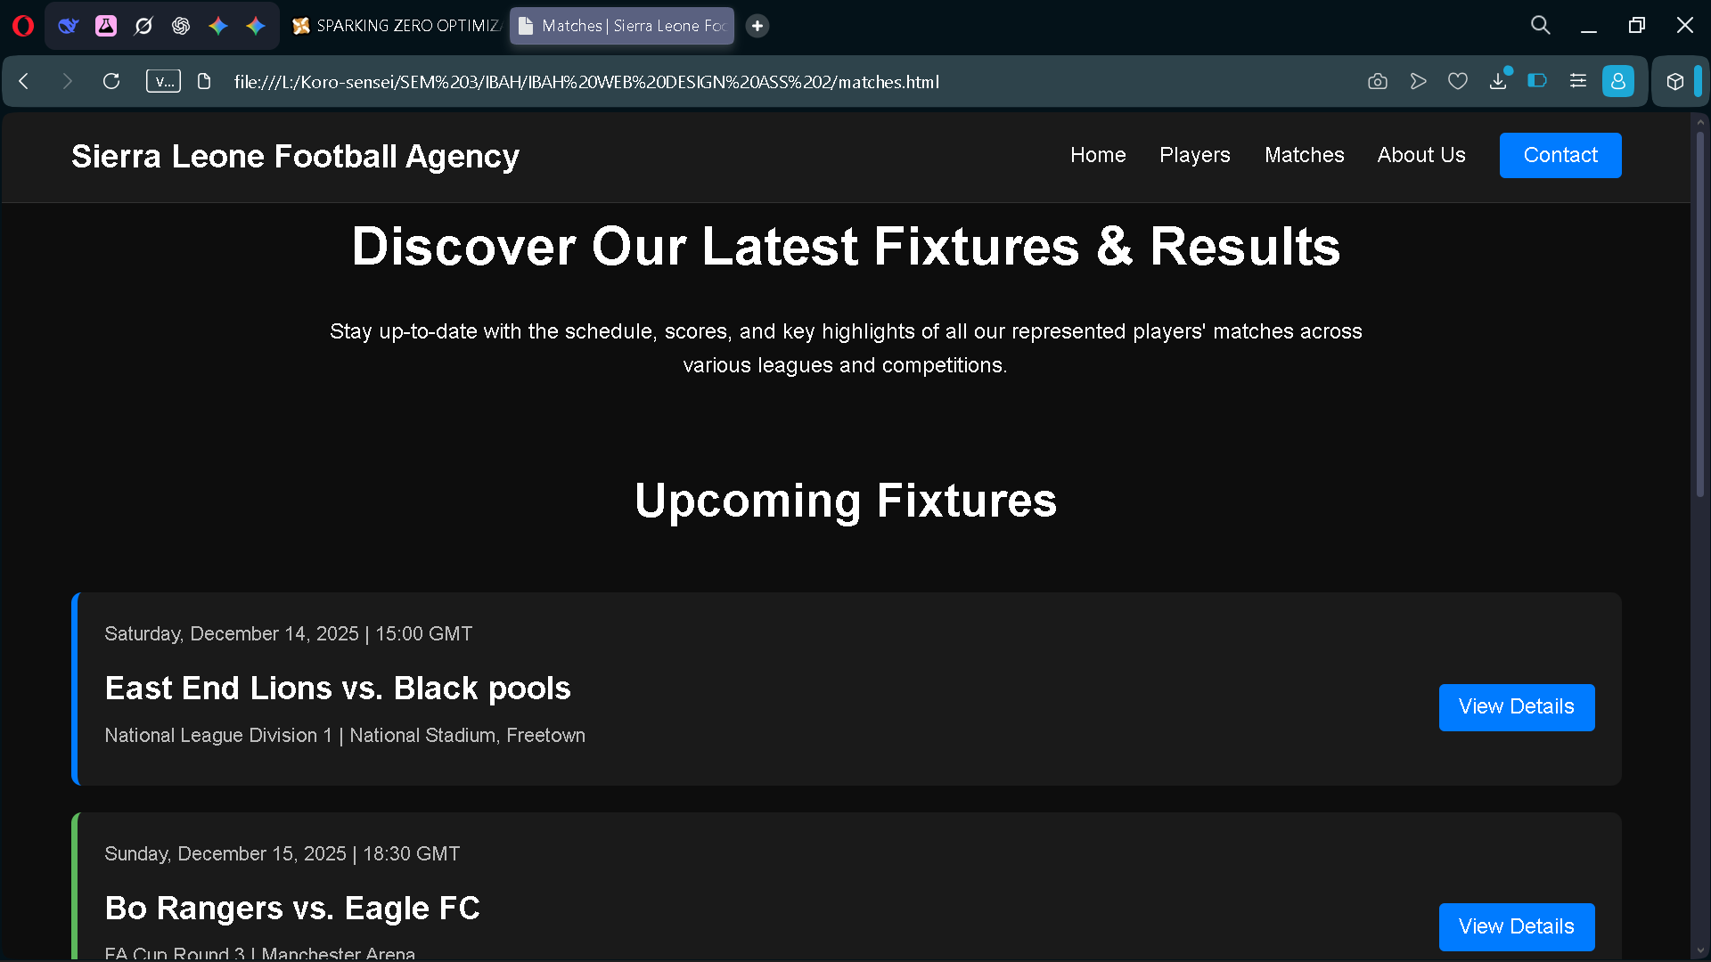

MATCHES PAGE SCREENSHOT

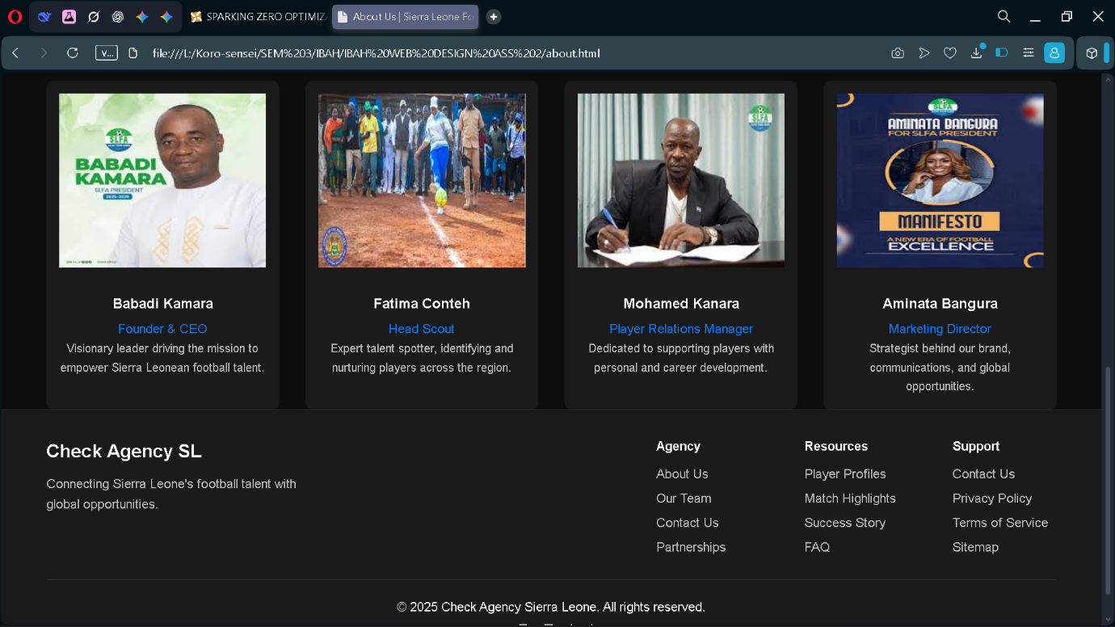

ABOUT US PAGE SCREENSHOT

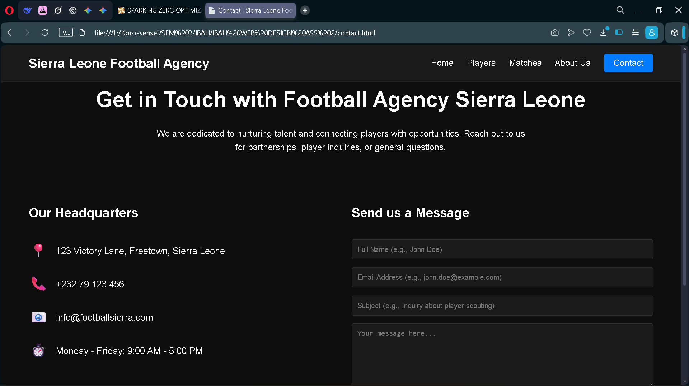

HOME PAGE CODE
<!DOCTYPE html>
<html lang="en">
<head>
<meta charset="UTF-8">
<meta name="viewport" content="width=device-width, initial-scale=1.0">
<title>Home | Sierra Leone Football Agency</title>
<link rel="stylesheet" href="styles.css">
</head>
<body>
<header>
<div class="container navbar">
<a href="index.html" class="logo">Sierra Leone Football Agency</a>
<ul class="nav-links">
<li><a href="index.html">Home</a></li>
<li><a href="players.html">Players</a></li>
<li><a href="matches.html">Matches</a></li>
<li><a href="about.html">About Us</a></li>
<li><a href="contact.html" class="contact-btn">Contact</a></li>
</ul>
</div>
</header>

<main>
<section class="hero-section container">
<img src="celeberating.jpeg" alt="A large image of a successful Sierra Leonean football player celebrating" class="hero-image" with style="max-height:00px; object-fit: cover; border-radius: 8px;">
<div class="hero-text">
<h1>Empowering Sierra Leone's Football Talent</h1>
<p>Discover the next generation of football stars from Sierra Leone. We scout, train, and manage athletes, connecting them with opportunities globally.</p>
<div>
<a href="about.html" class="btn">Explore Agency</a>
<a href="players.html" class="btn" style="background-color: var(--secondary-color);">Discover Our Stars</a>
</div>
</div>
</section>

<section class="latest-news">
<div class="container">
<h2 class="section-title">Latest News & Updates</h2>
<div class="grid-3">
<div class="card">
<img src="signing.jpeg" alt="Handshake agreement for a new player signing" class="card-image-placeholder">
<p style="color: var(--accent-color);">October 26, 2025</p>
<h4>Sierra Leone Agency Signs New Talent</h4>
<p>We announce a key signing...</p>
<a href="#" style="font-size: 0.9em; color: var(--accent-color);">Read More &rarr;</a>
</div>
<div class="card">
<img src="victory.jpg" alt="Youth football team celebrating a tournament victory" class="card-image-placeholder">
<p style="color: var(--accent-color);">October 18, 2025</p>
<h4>Victory in Local Youth Tournament</h4>
<p>Our youth team claims championship title...</p>
<a href="#" style="font-size: 0.9em; color: var(--accent-color);">Read More &rarr;</a>
</div>
<div class="card">
<img src="scouting.jpeg" alt="Scouts observing football training session" class="card-image-placeholder">
<p style="color: var(--accent-color);">October 10, 2025</p>
<h4>Scouting for Future Stars Concludes</h4>
<p>The latest scouting tour wraps up...</p>
<a href="#" style="font-size: 0.9em; color: var(--accent-color);">Read More &rarr;</a>
</div>
</div>
</div>
</section>

<section class="agency-highlights" style="padding: 80px 0;">
<div class="container">
<h2 class="section-title">Agency Highlights</h2>
<video controls style="width: 100%; min-height: 400px; background-color: var(--secondary-color); margin-bottom: 20px;">
<source src="JUMA.mp4" type="video/mp4">
Your browser does not support the video tag.
</video>
<h3>Celebrating Our Latest International Signing!</h3>
<p>Witness the journey of Juma Bah, as he takes his talent from Freetown to the global stage, representing Sierra Leone with pride.</p>
</div>
</section>
</main>
<footer>
<div class="container">
<div class="footer-top">
<div class="agency-info">
<a href="index.html" class="logo">Football Agency Sierra Leone</a>
<p style="color: #bbb; margin-top: 10px;">Connecting Sierra Leone's football talent with global opportunities.</p>
</div>
<div class="footer-links">
<div><h4>Product</h4><ul><li><a href="players.html">Players</a></li><li><a href="matches.html">Fixtures</a></li><li><a href="#">Training</a></li></ul></div>
<div><h4>Company</h4><ul><li><a href="about.html">About Us</a></li><li><a href="#">Team</a></li><li><a href="contact.html">Contact</a></li><li><a href="#">Partnerships</a></li></ul></div>
<div><h4>Resources</h4><ul><li><a href="#">Player Profiles</a></li><li><a href="#">Match Highlights</a></li><li><a href="#">Success Story</a></li><li><a href="#">FAQ</a></li></ul></div>
<div><h4>Legal</h4><ul><li><a href="#">Privacy Policy</a></li><li><a href="#">Terms of Service</a></li><li><a href="#">Sitemap</a></li></ul></div>
</div>
</div>
<p>&copy; 2025 Football Agency Sierra Leone. All rights reserved.</p>
<div class="social-links"><a href="#">F</a> <a href="#">T</a> <a href="#">I</a> <a href="#">L</a></div>
</div>
</footer>
</body>
</html>

